International Graduate Debate
CALL FOR APPLICATIONS

26-29 June 2023 | Estoril

“Rebuilding the Democratic Consensus at Home and Abroad”
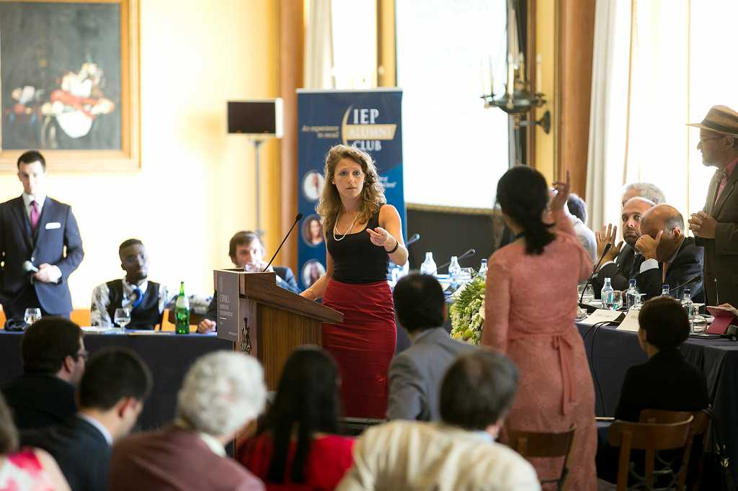
The 31st edition of the Estoril political forum—organised by the Institute for Political Studies of the Catholic University of Portugal, Lisbon—marks the 650th anniversary of the Anglo-Portuguese alliance. The meeting brings together leading policymakers and academics from the US, UK, Portugal and the rest of Europe.
This year’s hosts and guest speakers include: José Manuel Barroso (former Prime Minister of Portugal; former President of the European Commission; Director, IEP-UCP Centre for European Studies, Lisbon); Timothy Garton Ash (Professor of European Studies and Isaiah Berlin Professorial Fellow, St. Antony’s College, Oxford; Senior Fellow, The Hoover Institution, Stanford University); HE Ana Martinho (Ambassador of Portugal).
As usual, the Europaeum will host the 'Europaeum Special Debate'. This is a public event in the style of an Oxford Union debate. It is led by four Europaeum graduate students, alongside students from the Catholic University of Portugal and Jagiellonian University, each speaking for or against the given proposition, with expert commentators at hand. The event concludes with an open vote on the proposition. The motion to be debated will be: “democracy is the good management of conflict not the pursuit of consensus.”
Successful applicants will have their accommodation, travel and board (including three conference dinners) covered for this three-day conference. They are expected to book their own travel and will be reimbursed during the conference.
To apply, please send a completed application form, CV, reference letter, and a 300 word response to the debate topic:
“Democracy is the good management of conflict not the pursuit of consensus”
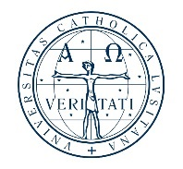
To: applications@europaeum.org by Friday 26th May 2023. If your application has been successful, you will be notified on 1 June 2023.

Applicants must be postgraduates (master’s or PhD) and must be attending a university that is a member of the Europaeum network.
Please note that Jagiellonian students can take part via a separate scholarship scheme run by the Catholic University, Portugal. As such we are not able to accept applications for Estoril 2023 from Jagiellonian applicants.

